Отчет по лабораторной работе № 7
по курсу «Математическое моделирование»
«Моделирование задачи стефана»

Выполнил: студент 4 курса группы ПМИ-22
Архипов Василий Олегович

Якутск, 2025
Постановка задачи
Задача Стефана:
$$(α\left(ϕ_{∆}\right)+ρ^{+}L\frac{dϕ_{∆}}{dt})\frac{dT}{dt}-div\left(λ\left(ϕ_{∆}\right)gradT\right)=0$$
$$α\left(ϕ\right)=c^{-}ρ^{-}+ϕ\left(c^{+}ρ^{+}-c^{-}ρ^{-}\right),$$
$$λ\left(ϕ\right)=λ^{-}+ϕ\left(λ^{+}-λ^{-}\right),$$
$$ϕ=\left\{\begin{aligned}0, T<T^{*} \\ 1, T>T^{*}\end{aligned}\right.$$
Начальное условие
$$T\left(x,0\right)=2, x∈Ω$$
Граничные условия
$$T\left(x,t\right)=-10, x∈Г_{1}$$
$$-k\frac{∂T}{∂n}=0, x∈Г_{2}$$
$Г_{1}$ – место контакта с замораживающим каналом

Конечно-элементная аппроксимация
Применим МКЭ:
$$\int_{Ω}{(α\left(ϕ_{∆}\right)+ρ^{+}L\frac{dϕ_{∆}}{dt})\frac{dT}{dt}vdx}+\int_{Ω}{(λ\left(ϕ_{∆}\right)gradT,gradv)vdx}=0$$

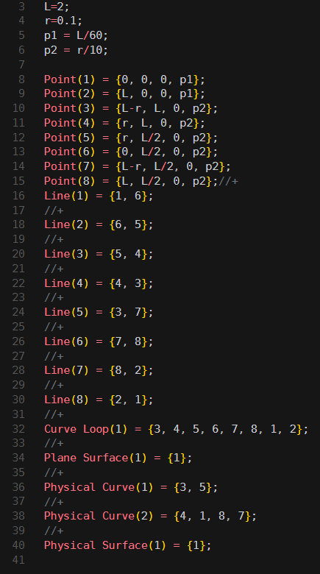

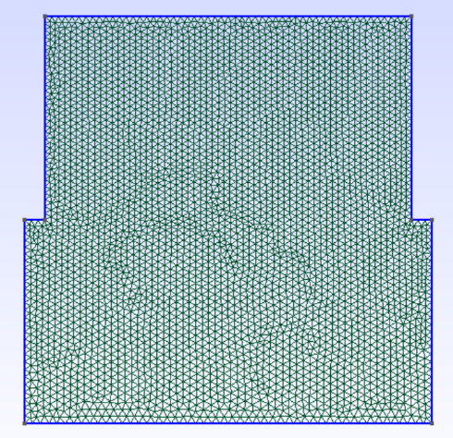

import time
from dolfin import *

meshname = "mesh2"
mesh = Mesh(meshname + ".xml")
subdomains = MeshFunction("size_t", mesh, meshname + "_physical_region.xml")
boundaries = MeshFunction("size_t", mesh, meshname + "_facet_region.xml")

Q = FunctionSpace(mesh, "CG", 1)
DAY = 86400
Month = 30*DAY
tau = 0.5*DAY

sou = Constant(-10.0)
rhoL = Constant(6.0*1.0e7)
croS = Constant(2.0*1.0e6) #c-pho-
croL = Constant(2.5*1.0e6) #c+pho+
kS = Constant(1.8) #lambda-
kL = Constant(2.0) #lambda+
delta = Constant(1.0)

initT = Constant(2.0)
T0 = interpolate(initT, Q)

phi = conditional(gt(T0, delta), 1.0, conditional(lt(T0, -delta), 0.0,
(T0+delta)/(delta+delta)))
dphi = conditional(gt(T0, delta), 0.0, conditional(lt(T0, -delta),
0.0, 1.0/(delta+delta)))

k = kS + phi*(kL - kS) #lambda(phi)
cro = croS + phi*(croL - croS) #alpha(phi)

w = Function(Q)

bc = DirichletBC(Q, sou, boundaries, 1)

T = TrialFunction(Q)
v = TestFunction(Q)

dx = Measure('dx', domain=mesh, subdomain_data=subdomains)
ds = Measure('ds', domain=mesh, subdomain_data=boundaries)

a = (cro + rhoL*dphi) * T/tau*v*dx + inner(k * grad(T), grad(v))*dx
L = (cro + rhoL*dphi) * T0/tau*v*dx

file = File("/mnt/c/Users/admin/Downloads/T1.pvd")

start_time = time.time()
t = tau

solver = KrylovSolver('bicgstab', 'ilu')
cg_prm = solver.parameters
cg_prm["absolute_tolerance"] = 1E-7
cg_prm["relative_tolerance"] = 1E-4
cg_prm["maximum_iterations"] = 1000

while t < Month:
res = w.vector()
t += tau
A = assemble(a)
b = assemble(L)

iter = solver.solve(A, res, b)
print(iter)

T0.assign(w)

file << w

solve_time = time.time() - start_time
print(solve_time, "seconds")

Результат
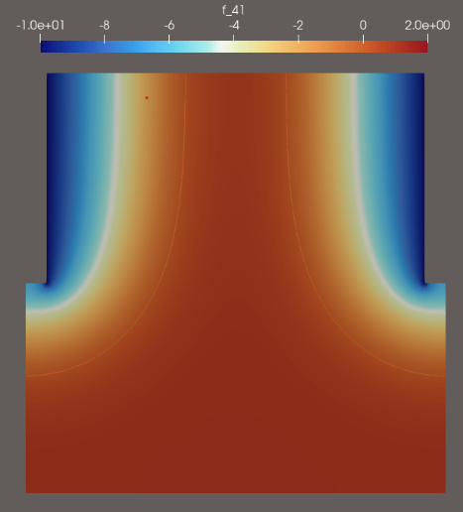
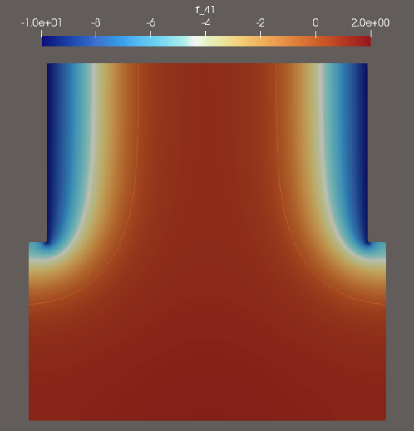
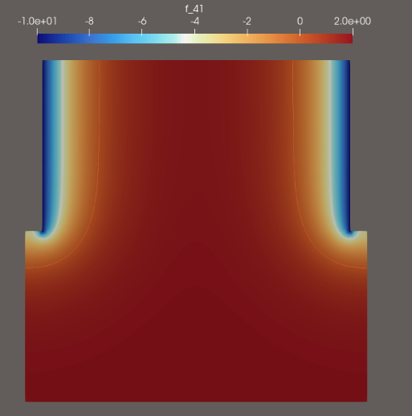

методы | предобуславливатели | итерация | время
cg | ilu | 19 | 3.416037082672119
cg | hypre_amg | 2 | 3.5855274200439453
cg | amg | 2 | 3.8267242908477783
cg | hypre_euclid | 2 | 3.7030189037323
cg | hypre_parasails | 2 | 3.7040607929229736
cg | icc | 19 | 3.4205474853515625
cg | jacobi | 64 | 3.521804094314575
cg | none | 69 | 3.4748334884643555
cg | petsc_amg | 3 | 3.811605930328369
cg | sor | 26 | 3.4775173664093018
gmres | ilu | 2 | 3.5320541858673096
gmres | Hypre_amg | 19 | 3.401923656463623
gmres | amg | 2 | 3.887655019760132
gmres | hypre_euclid | 2 | 3.6908743381500244
gmres | hypre_parasails | 2 | 3.740675687789917
gmres | icc | 19 | 3.4338879585266113
gmres | jacobi | 65 | 3.613780975341797
gmres | none | 72 | 3.6860785484313965
gmres | petsc_amg | 3 | 3.365311861038208
gmres | sor | 25 | 3.513618230819702
bicgstab | ilu | 13 | 3.445087194442749
bicgstab | hypre_amg | 1 | 3.776381015777588
bicgstab | amg | 1 | 3.8303892612457275
bicgstab | hypre_euclid | 1 | 3.7285218238830566
bicgstab | hypre_parasails | 1 | 3.710144281387329
bicgstab | icc | 13 | 3.419598340988159
bicgstab | jacobi | 48 | 3.585207939147949
bicgstab | none | 49 | 3.5224192142486572
bicgstab | petsc_amg | 2 | 3.8463122844696045
bicgstab | sor | 19 | 3.58740234375
minres | ilu | 19 | 3.4362752437591553
minres | hypre_amg | 2 | 3.2084577083587646
minres | amg | 2 | 3.8208553791046143
minres | hypre_euclid | 2 | 3.1978397369384766
minres | hypre_parasails | 2 | 3.6638550758361816
minres | icc | 19 | 3.483943223953247
minres | jacobi | 61 | 3.5059337615966797
minres | none | 61 | 3.5516130924224854
minres | petsc_amg | 4 | 3.8042428493499756
minres | sor | 25 | 3.517596483230591
richardson | ilu | 121 | 3.785963296890259
richardson | hypre_amg | 3 | 3.736388921737671
richardson | amg | 2 | 3.283663272857666
richardson | hypre_euclid | 3 | 3.7232754230499268
richardson | hypre_parasails | 3 | 3.661958694458008
richardson | icc | 121 | 3.7962703704833984
richardson | jacobi | ошибка
richardson | none | ошибка
richardson | petsc_amg | 7 | 3.8292953968048096
richardson | sor | 1000 | 6.663969039916992
tfqmr | ilu | 16 | 3.4662065505981445
tfqmr | hypre_amg | 1 | 3.598081111907959
tfqmr | amg | 1 | 3.7872977256774902
tfqmr | hypre_euclid | 1 | 3.679589033126831
tfqmr | hypre_parasails | 1 | 3.6638948917388916
tfqmr | icc | 16 | 3.495074510574341
tfqmr | jacobi | 53 | 3.5803658962249756
tfqmr | none | 55 | 3.5930545330047607
tfqmr | petsc_amg | 3 | 3.680821180343628
tfqmr | sor | 19 | 3.5201165676116943
default | ilu | 19 | 3.4429867267608643
default | hypre_amg | 2 | 3.689638137817383
default | amg | 2 | 3.404705286026001
default | hypre_euclid | 2 | 3.716562271118164
default | hypre_parasails | 2 | 3.7061870098114014
default | icc | 19 | 3.478268623352051
default | jacobi | 65 | 3.618075132369995
default | none | 72 | 3.6288187503814697
default | petsc_amg | 3 | 3.7887485027313232
default | sor | 25 | 3.1667232513427734

